# SmartDesk: Simplifying Workspace Problems

**Pratik Kamble | August 29, 2019**

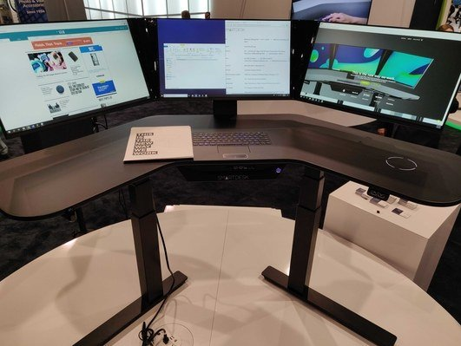

Figure 1: SmartDesk

Even with all the advanced products and newer technologies available to companies, many companies still have their offices set up in an archaic manner. Other problems are clunky and cluttered workspaces which do not promote creativity and technologies that are incompatible with each other. Below are few problems that every office manager should consider changing.

## Cluttered Workspaces

There is a negative impact on individual’s ability, if an office space is cluttered. Also reduces the focus and can significantly decrease productivity. A study conducted at Princeton University compared people’s ability to complete a task in an organized and a disorganized environment. Due to increase in physical clutter the individual’s attention reduces from the task. This results to individual’s decrease in the performance and increase in the stress levels.

## Incompatible Technology

Often times the machines in a workspace are a mixed collection of various brands, types and quality that are not designed to work together. There is no proper pull and analysis of data about the organization, when systems are not working together. The best decisions are not made for the company without analysis about work process like where to improve efficiencies.

## Less Ergonomic Support

Traditional office furniture lacks the ergonomic support which results in health issues of your employees. One of the best ways to improve the ergonomics of a workspace is with standing desks which can be fulfilled with Cemtrex SmartDesk. Benefits include:

### Improved productivity

The employee’s productivity improves with good posture, less exertion and sitting at better heights with Smartdesk work station.

### Improved Quality

A workspace with optimized will reduce the employees physical fatigue, which will increase the quality of their work at its highest.

### Improved safety

By upgrading the ergonomics of your workspace, you are signaling that your company is committed to the health and safety of its employees. The strong safety culture of the workplace indicates less fatigue, less exertion and less injuries.

### Compensation reduction

When there is a healthy environment for employees to work in, they are less fatigued and the job injuries will decreased. This will decrease your workers compensation and other health care costs.

### Increased employee involvement

By investing in ergonomic office equipment, indicates that you care about the individuals working for you. This will have a direct impact on the employee involvement rate within your company.

## Misplaced Wires

A nest of tangled wires behind every machine and underneath each desk is the least attractive aspect of a traditional workspace. This shows that workplace has not adapted any newer technology. These misplaced wires can pose multiple hazards.

These hazards include:

* Increased risk of fire
* Increased risk of an electric short circuit
* Damage to the electronics through power loss

Many technologies are available today for its users for wireless compatibility and in this come a newly launched technology of Cemtrex SmartDesk-The World’s Most Advanced Workstation. Let us look into some specifications of Cemtrex SmartDesk.

## Specifications

### Processor

8th-Generation Intel Core i7-8700 Processor

### Graphics

Nvidia 1060

### Storage

SSD 256GB + 1TB or 2TB HDD

### RAM

16GB or 32GB of DDR4

### Displays

(3) – 24 inch (23’’ diagonal)

### Dimensions

Minimum (Sitting) 59.7’’ × 33.7’’ × 38.9’’

Maximum (Standing) 59.7’’ × 33.7’’ × 64.4’’

### Weight

54 kg

### Finish

 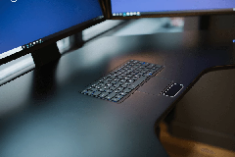

Piano Black Matte Black

### Ports

1. USB 3.1 type C
2. USB 3.1 type A
3. USB 2.0

3.5mm Mic in/Stereo headphone out RJ45/Ethernet Interface

### Sensors

Leap Motion Gesture Controller

### Wireless Phone Charger

10W Fast Charging Qi Wireless Power Charging v1.2.3

### Speakers

(2)-Front-facing stereo speakers

### Microphone

High-Performance, Stereo Array with Noise Cancellation

### Face Camera

5.0 megapixel 1080p@30fps

### Document Scanner

Hi-Res Document Scanner

### Desk

Motorized leg system (sit/stand) / Adjustable from 23.7’’ to 49.3’’

### Keyboard

Integrated chiclet-style keyboard and trackpad

### Wireless

802.11AC Wi-Fi

Bluetooth 5.0

### Software

Windows 10 Pro OS, Document Scanner, Integrated Communications System, Advanced Content Management System

### Warranty

1 year (parts) / 1 year (labor)

### Price

Starting at $2,999

## Conclusion

Our work cultures have evolved significantly so far but not the work spaces in which we work. Employees spend unnecessary time working with incompatible devices. These problems can increase costs to companies, reduce productivity and cause disappointment to employees. To relieve these problems the companies should promote an environment with optimize ergonomics in the offices.

The Cemtrex SmartDesk is a solution to archaic technology in the workplace.

The SmartDesk is built as a fully integrated technology which can change the future of workspace technology. SmartDesk gives you everything you need to get the job done. This includes a beautiful sit/stand desk, powerful PC, built-in keyboard and multi-touch trackpad, wireless phone charging, a phone integration system and an integrated document scanner. All these come with just one wire.

When seamless software comes with advanced tools, productivity gets increase.

## Sources

* [www.engadget.com](http://www.engadget.com)
* [www.digitaltrends.com](http://www.digitaltrends.com)
* [www.cemtrex.com](http://www.cemtrex.com)
* **Videos** 
  + [www.smartdesk.com](http://www.smartdesk.com)
  + [www.youtube.com](http://www.youtube.com)